MySQL Assignment 2 – Querying Data
Step 1: Insert the Data
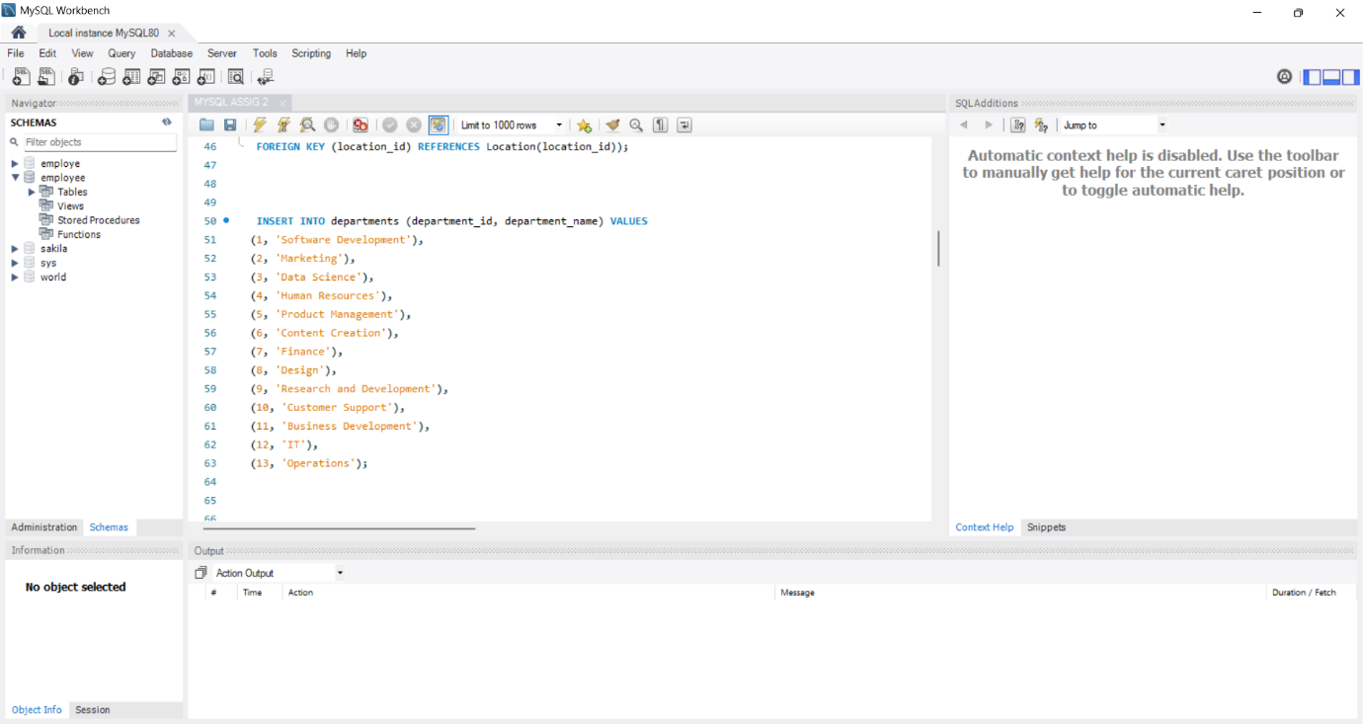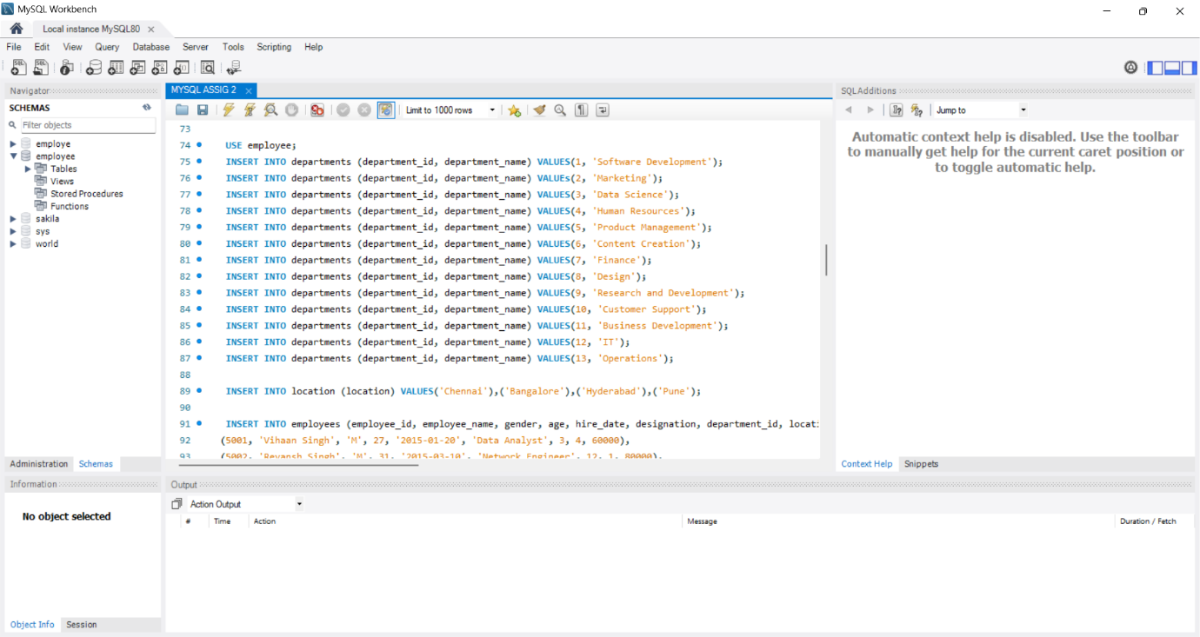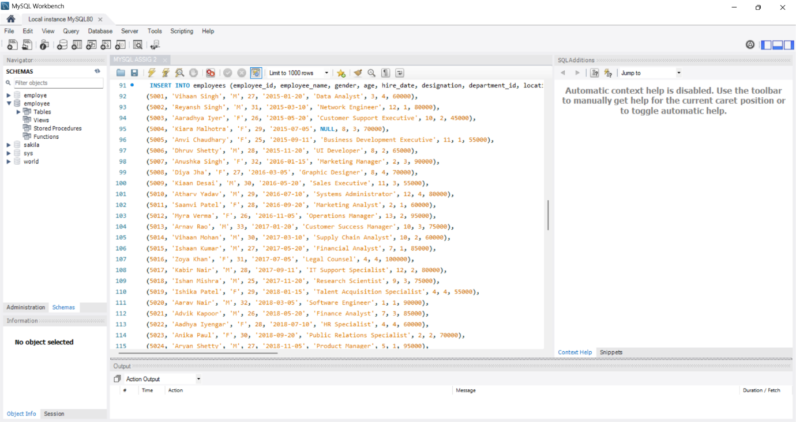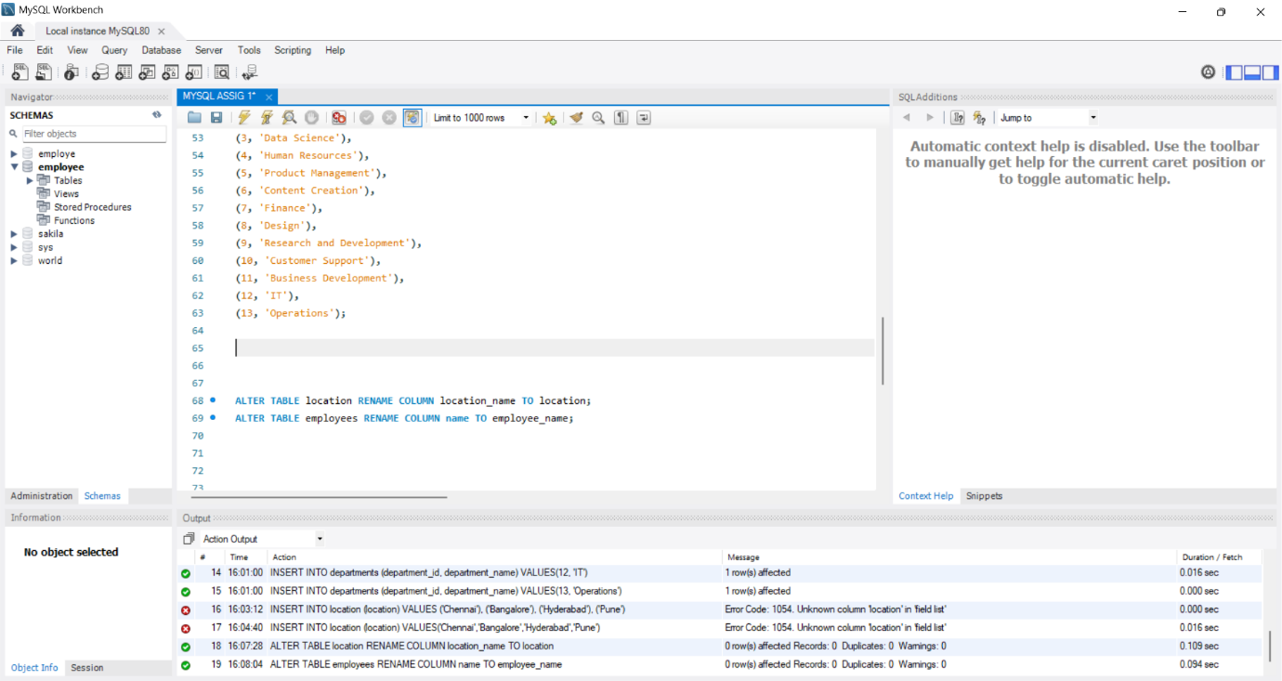1. Distinct Values:
⦿ a query to retrieve distinct salaries from the Employees table.
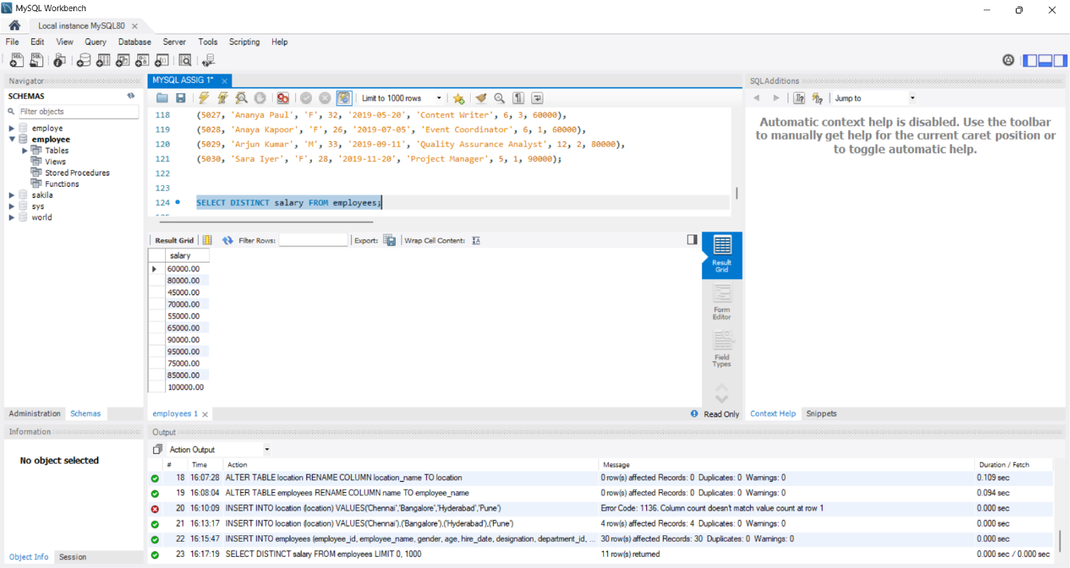 2. Alias (AS):

⦿ Provide aliases for the "age" and "salary" columns as "Employee_Age" and
"Employee_Salary", respectively 